**AUTOMATIC PLANT WATERING SYSTEM USING ARDUINO UNO BASED ON SOIL MOISTURE CONTENT**

**MOBILE AND PERVASIVE COMPUTING**

**(CSB3211)**

**SUBMITTED BY**

**GAYATRI .P ( 150071601022 )**

**AYISHA SAHANA ( 150071601017 )**

**AMINA SHAIK ( 150071601010 )**



**PROJECT**

**AUTOMATIC PLANT WATERING SYSTEM USING ARDUINO UNO BASED ON SOIL MOISTURE CONTENT**

**INDEX**

**S.No Contents Page No.**

1. Abstract...............................................................................................**04**

2. Introduction…………………………………………………………………**05**

3. Literature survey.……………………....................................................**06**

4. Problem Statement………………………………………………………..**11**

5. Design Process……………………………………………………….……**11**

5.1 Requirements………………………………………………………….....**11**

5.2 Architecture Diagram…………………………………………………….**17**

5.3 Module Description…………………………………………………........**18**

6. Implementation ………….………………………………………………....**19**

7.Conclusion………………………………………………………….…..…...**21**

8. Future work………………………………………………………………….**22**

9.Screenshot……………………………………………………………….…..**23**

**1. ABSTRACT**

Suitable environmental conditions are required for best plant growth ,improved crop yields, and efficient use of water and other resources. Automating the data gaining process of the soil condition allows plant growth with less struggle .The existing system make use of PC or SMS-based systems for keeping the user continuously informed of the conditions of the field; but too expensive, massive, difficult to maintain and less acknowledged by the technically unskilled workers.

The idea of this project is to design a simple, easy to install arduino-based circuit to scrutinize and detect the values of soil moisture content level that are continuously determined based on which the water flow to the plants are controlled. This is done in order to optimize them to accomplish utmost plant growth and yield. The arduino board used is a simple open source and cost efficient microcontroller. It communicates with the sensor modules through the relay module in real-time in order to control the plant watering process economically inside a field by actuating a motor according to the needed circumstance of the crops. An integrated arduino with relay is also used for real time display of data acquired from the sensor. Also, the use of easily accessible components reduces the manufacturing and maintenance costs. The design is simply flexible as the software can be changed any time. It can thus be specially-made to the specific requests of the user.

This makes an proficient structure for optimization of yield with minimum use of water. This system is also cost effective, handy and user friendly.

The purpose of the project is mainly to maintain water consumption, human labour and power usage . The system is more useful for people who travel .If the system is assembled and programmed effectively, automatic plant watering system helps us save money and in conserving water. The automatic plant watering system can used to release necessary amount of water to the desired area which in turn promoting water conservation. The cost of building the project may be high but the saving from establishing the system will be more than that. The system once built may take much money but the after effect and savings from system is everlasting.. This system is also cost effective, handy and user friendly.

**2. INTRODUCTION**

The water harvesting is the mainstay of agriculture industry. In case of India a lot of water gets unexploited due to numerous provinces resulting in failure of fulfilment of requirement of water for farming causing to lesser yield in agriculture. Because of the unmindful unsuitable preservation and erroneous water harvesting planning the irrigation of water is also the main calamity. Day by day the percentage of rain is also becoming less adding on to the water crisis and so a very small quantity of water is vacant for the farming purposes which is more needed. water percentage is also getting decreased nowadays mainly due to lack of proper awareness by farmer causing them to waste it not knowing its original worth and need.

To deal with this problem the “Automatic Plant Watering System” in which an moisture sensor is used which senses the amount of moisture content in the soil and facilitates mechanical as well as automatic watering of plants. We can recognise the water content level in the soil by using the soil moisture sensor and based on its output accordingly the motor runs. The core of the system is microcontroller based arduino UNO with a relay module and a motor with a sensor. A simple assembly language program can perform all required operations.

India is an country where agriculture plays the substantial role in the economy and enhancement of the country. This process of irrigation often consumes further water or sometimes the water may not reach on time due to which the crops get dried or the water may not be sufficient for crops too. There is demanding in the inhabited and the commercial irrigation industry for an plant watering management which is smart enough and equipped so that it responds to soil moisture content read by sensors in individual zones as a way of safeguarding water. Moreover, the system should be designed easy to trouble shoot in the cases such as occurrence of faults in any of the multiplicity of zones.

The project is intended to develop an automatic plant watering system where there is automatic switching of the pump motor as ON/OFF depending on picking up the moisture content of the soil. In the field of agriculture, use of proper method of plant watering system is noteworthy. The benefit of using this technique is to diminish human intrusion and to assure appropriate watering to plants.

**3. LITERATURE SURVEY**

IEEE International Research Journal of Engineering and Technology (IRJET) e-ISSN: 2395 -0056 Volume: 03 Issue: 03 | Mar-2016 www.irjet.net p-ISSN: 2395-0072 © 2016, IRJET | Impact Factor value: 4.45 | ISO 9001:2008 Certified Journal Automatic plant watering System on Sensing Soil Moisture Content

**ABSTRACT-**

This project on "Automatic Irrigation System on Sensing Soil Moisture Content" is intended to create an automated irrigation mechanism which turns the pumping motor ON and OFF on detecting the moisture content of the earth. In the domain of farming, utilization of appropriate means of irrigation is significant. The benefit of employing these techniques is to decrease human interference and still make certain appropriate irrigation. This automated irrigation project brings into play an Arduino board ATmega328 micro-controller ,is programmed to collect the input signal of changeable moisture circumstances of the earth via moisture detecting system. Key Words: Arduino, Irrigation, Soil Moisture Sensor, Automated Irrigation Mechanism.

1. **INTRODUCTION**

Continuous increasing demand of food requires the control in highly specialized greenhouse vegetable rapid improvement in food production technology. In a production and it is a simple, precise method for country like India, where the economy is mainly based on irrigation. It also helps in time saving, removal of human agriculture and the climatic conditions are isotropic, still error in adjusting available soil moisture levels and to we are not able to make full use of agricultural resources. Maximize their net profits.

The main reason is the lack of rains & scarcity of land Irrigation is the artificial application of water to the soil reservoir water. The continuous extraction of water from usually for assisting in growing crops. In crop production earth is reducing the water level due to which lot of land is it is mainly used in dry areas and in periods of rainfall coming slowly in the zones of un-irrigated land. Another shortfalls, but also to protect plants against frost.

Very important reason of this is due to unplanned use of Types of Irrigation water due to which a significant amount of water goes to surface irrigation waste. Localized irrigation in modern drip irrigation systems, the most significant Drip Irrigation advantage is that water is supplied near the root zone of sprinkler irrigation. The plants drip by drip due to which a large quantity of water is saved.

At the present era, the farmers have been the conventional irrigation methods like overhead using irrigation techniques in India through manual control sprinklers, flood type feeding systems usually wet the in which farmers irrigate the land at the regular intervals. Lower leaves and stem of the plants. The complete soil in this process sometimes consumes more water or surface is saturated and often stays wet long after irrigation sometimes the water reaches late due to which crops is completed. Such condition promotes infections by leaf get dried. Water deficiency can be a serious problem to plants. On the contrary the drip or trickle irrigation is before visible wilting occurs. Slowed growth rate, lighter a type of modern irrigation technique that slowly applies weight fruit follows slight water deficiency.

**2. IRRIGATION**

Little water is lost to deep percolation if the proper amount is applied. Drip irrigation is popular because it can Irrigation system uses valves to turn irrigation ON and increase yields and decrease both water requirements and OFF. These valves may be easily automated by using labour. Controllers and solenoids. Automating farm or nursery Drip irrigation requires about half of the water needed by irrigation allows farmers to apply the right amount of sprinkler or surface irrigation.

Lower operating pressures water at the right time, regardless of the availability of and flow rates result in reduced energy costs. International Research Journal of Engineering and Technology (IRJET) e-ISSN: 2395 -0056 Volume: 03 Issue: 03 | Mar-2016 www.irjet.net p-ISSN: 2395-0072 © 2016, IRJET | Impact Factor value: 4.45 | ISO 9001:2008 Certified Journal | Page 207 A higher labour to turn valves on and off. In addition, farmers using degree of water control is attainable. Automation equipment are able to reduce runoff from over Plants can be supplied with more precise amounts of watering saturated soils, avoid irrigating at the wrong time water. Disease and insect damage is reduced because plant of day, which will improve crop performance by ensuring foliage stays dry. Operating cost is usually reduced. Adequate water and nutrients when needed. Automatic Federations may continue during the irrigation process Drip Irrigation is a valuable tool for accurate soil moisture because rows between plants remain dry.

The capacity of soil to retain water is a function of soil texture and structure. When removing a soil sample, the soil being evaluated is disturbed, so its water-holding capacity is altered. Indirect methods of measuring soil water are helpful as they allow information to be collected at the same location for many observations without disturbing the soil water system. The new soil moisture sensor uses Immersion Gold which protects the nickel from oxidation.

**Overview of Automated Irrigation System**

Gold (ENIG) has several advantages over more conventional and cheaper surface plating such as excellent surface planarity measured for automation of irrigation system are soil (particularly helpful for PCB's with large BGA packages), moisture. The entire field is first divided into small good oxidation resistance, and usability for untreated sections such that each section should contain one contact surfaces such as membrane switches and contact moisture sensor.

These sensors are buried in the ground at points required depth. Once the soil has reached desired moisture a soil moisture sensor can read the amount of level the sensors send a signal to the micro controller to moisture present in the soil surrounding it. It's a low tech turn on the relays, which control the motor. Sensor but ideal for monitoring an urban garden. In proposed system, automated irrigation pet plant's water level. This is a must have tool for a mechanism which turns the pumping motor ON and OFF connected garden.

On detecting the dampness content of the earth. In this sensor uses the two probes to pass current through domain of farming, utilization of appropriate means of the soil, and then it reads that resistance to get the irrigation is significant. The benefit of employing moisture level. More water makes the soil conduct these techniques is to decrease human interference. Electricity more easily (less resistance), while dry soil this automated irrigation project, the soil sensor senses conducts electricity poorly (more resistance). The moisture content by giving input signal to an Arduino board which operates on ATmega328 micro-controller, is programmed to collect the input signal of changeable dampness circumstances of the earth via dampness detecting system. Because this method is based on ultimately profit. , it is the standard with which all other methods are compared.

**3. SOIL MOISTURE**

Soil moisture is an important component in the atmospheric water cycle, both on a small agricultural scale and in large scale modelling of land/atmosphere interaction. Vegetation and crops always depend more on the moisture available at root level than on precipitation occurrence. Water budgeting for irrigation planning, as well as the actual scheduling of irrigation action, requires local soil moisture information. Knowledge of the degree of soil wetness helps to forecast the risk of flash floods, or the occurrence of fog. Block diagram of the system Soil water content is an expression of the mass or volume. The above fig 2 shows Microcontroller based irrigation of water in the soil, while the soil water potential is a system proves to be a real time feedback control system expression of the soil water energy status. The relation which monitors and controls all the activities of drip between content and potential is not universal and depends irrigation system efficiently. The present proposal is based on the characteristics of the local soil, such as soil density model to modernize the agriculture industries on a small and soil texture. Using this system, is the basic technique for measuring soil water content to save manpower, water to improve production and gravimetric method. Because this method is based on ultimately profit. Direct measurements, it is the standard with which all other methods are compared.

**4. RESULT**

Irrigation becomes easy, accurate and practical with the soil sample moisture content values. Because of this reason this idea can be implemented in agricultural difficulties of accurately measuring dry soil and water fields in future to promote agriculture to next level. The Volumes, volumetric water contents are not usually output from moisture sensor and level system plays major determined directly.

**5.CONCLUSION**

The primary applications for this project are for farmers and gardeners who do not have enough time to water their Crops/plants. It also covers those farmers who are wasteful of water during irrigation. The project can be extended to greenhouses where manual supervision is far and few in between. The principle can be extended to create fully automated gardens and farmlands. Combined with the principle of rain water harvesting, it could lead to huge water savings if applied in the right manner. In agricultural lands with severe shortage of rainfall, this model can be successfully applied to achieve great results with most types of soil.

**4. PROBLEM STATEMENT**

A automated plant watering system is designed that uses sensor technology with arduino Uno to make a smart automatic watering device for plants. This project represents the basic mechanism of a motor that allows the flow of water to plants based on the soil moisture content of the soil.

This type of system is often employed for general plant care, as part of caring for small and large gardens. Normally, the plants need to be watered whenever moisture content is low in the soil. So, the ardunio is programmed in such a way that the plants are watered whenever the soil moisture content is low.

**5. DESIGN PROCESS**

**5.1 COMPONENTS REQUIREMENT**

a. Soil moisture sensor

b. Ardunio UNO

c. Relay

d. Motor

e. Jumper wire Motor

f. Plug

**5.1 COMPONENTS DISCRIPTION**

**5.a SOIL MOISTURE SENSOR:**

Soil moisture sensor measures the water content in the soil. A soil moisture probe is made up of sensors. It uses two probes, when inserted in the soil provides the repeated moisture readings used for watering the plants.

By using some properties of the soil such as dielectric constant, neurons interaction and electrical resistance the water content in the soil is measured indirectly since the removing, drying and weighting of the soil sample is required by the free soil gravimetric measurement. The soil type, electrical conductivity and temperature will be varying depending on the surrounding factors in which the connection between the soil moisture and ranged property should be registered. Water content in the soil is estimated by the moisture sensors.

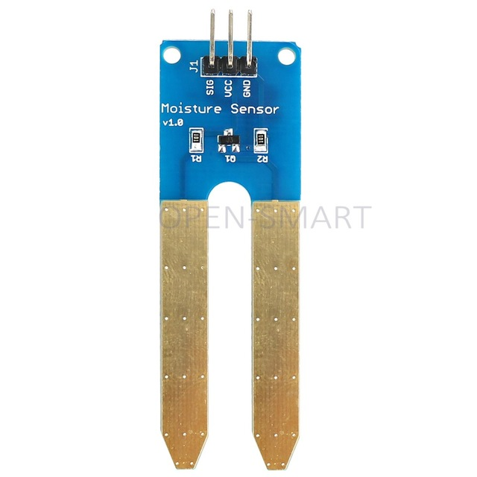

Fig 5.1.a

**b. ARDUNIO UNO**

The Arduino Uno is a microcontroller board based on the ATmega328. It has 14 digital input/output pins (of which 6 can be used as PWM outputs), 6 analog inputs, a 16 MHz ceramic resonator, a USB connection, a power jack, an ICSP header, and a reset button. It contains everything needed to support the microcontroller; simply connect it to a computer with a USB cable or power it with a AC-to-DC adapter or battery to get started.

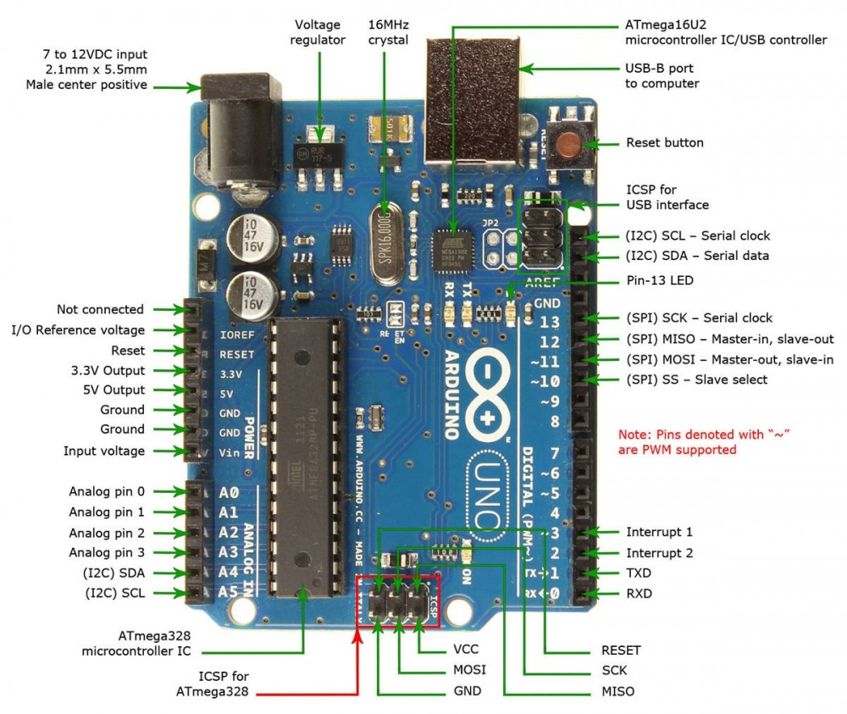

Fig 5.1.b

**ARDUINO UNO SPECIFICATIONS:**

The Arduino Uno can be powered via the USB connection or with an external power supply. The power source is selected automatically. External (non-USB) power can come either from an AC-to-DC adapter (wall-wart) or battery. The adapter can be connected by plugging a 2.1mm center-positive plug into the board's power jack. Leads from a battery can be inserted in the Gnd and Vin pin headers of the POWER connector.

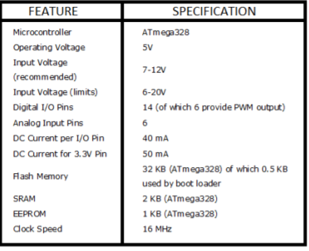

Fig 5.1.b

1. **4-CHANNEL RELAY MODULE**

It is an electric switch that use an electromagnet to move the switch from OFF to ON position instead of moving the switch. A **4**-**Channel Relay** interface **board** that allows us to control various appliances, and other equipment's with large current. It can be controlled directly by arduino.It is a single pole double throw relay used.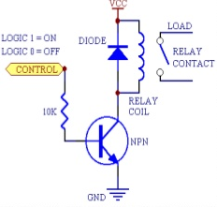

Fig 5.1.c

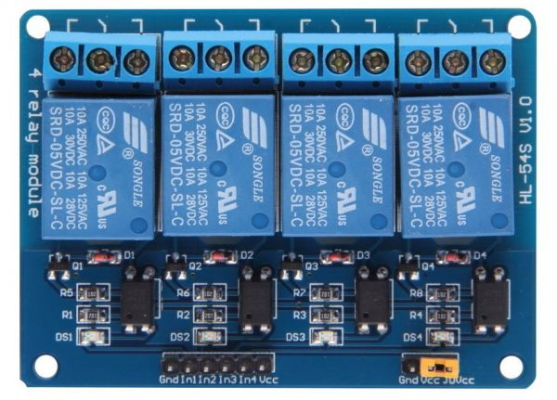

Fig 5.1.c

**d. DC MOTOR**

Electric motor is an electrical devices that converts the electrical energy into mechanical energy and vice versa and the vice verse action is done using the electric generator. The communication between magnetic field and winding currents creates a force inside the motor in the normal motoring mode.A **submersible pump** is a device which has a hermetically sealed motor close-coupled to the pump body. Submersible pumps push fluid to the surface as opposed to jet pumps having to pull fluids. Submersibles are more efficient than jet pumps and this is a direct current motor.

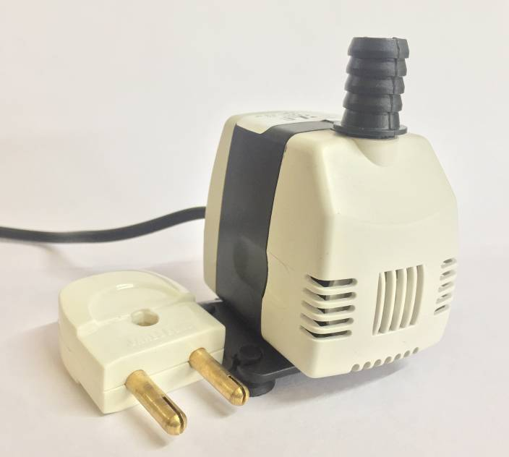

Fig 5.1.d

**e.JUMPER WIRE**

A jump **wire** is also known as jumper, jumper wire,jumpe**r** cable is an electrical wire, or group of them in a cable, with a connector or pin at each end or sometimes without them – simply "tinned", which is normally used to interconnect the components ofa breadboard or other prototype or test circuit, internally or with other equipment or components, without soldering.

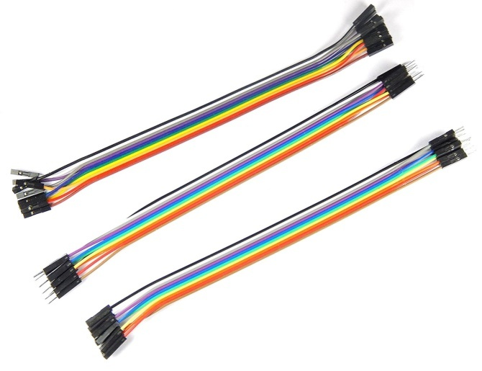

**Fig 5.1.e**

**f. PLUG**

An electrical connector, is an electro-mechanical device used to join electrical terminations and create an electrical circuit. Electrical connectors consist of plugs(male-ended) and jacks (female-ended).

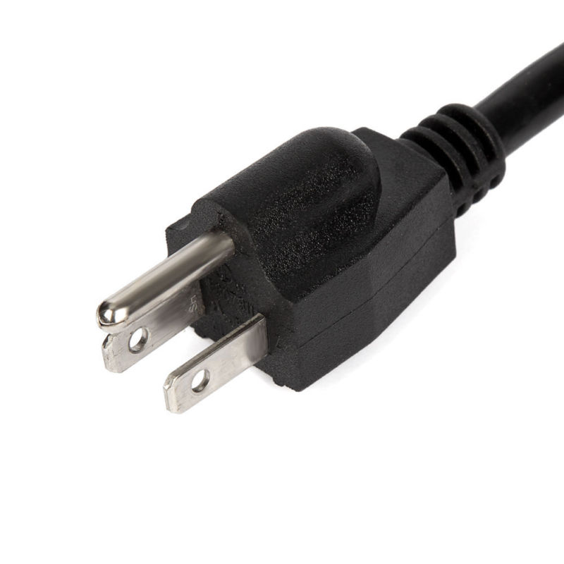

Fig 5.1.f

**CIRCUIT DIAGRAM**

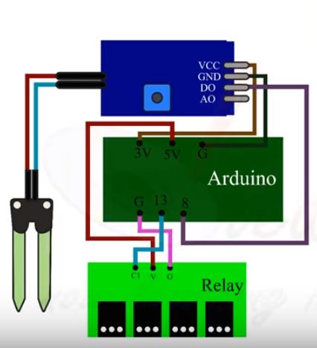

In this project, two sensors can be connected to analogue pins, A0 and A1, of the Arduino board. Each sensor has four pins (Vcc, Gnd, Ao and Do) available for interfacing with the Arduino board. Here, digital output pin (Do) is not used. The water pump and motor are controlled by Arduino connected to digital pins 3 and 9, respectively. That is, the motor signal control pin is connected to pin 9 of the Arduino board.

The program in the Arduino reads the moisture value from the sensor every 20 seconds. If the value reaches the threshold value, the program does the following:  
1. It runs the motor , along with the water pipe fixed on it, toward potted plant, whose moisture level is less than the predetermined/ threshold level.  
2. It starts the motor and supplies water to the plant for a fixed period of time and then stops.

**5.2 ARCHITECTURE DIAGRAM**

Motor

SOIL MOISTURE SENSOR

Dc source

RELAY MODULE

SENSOR CHIP

ARDUINO BOARD

MOISTURE SENSOR

ELECTRODES

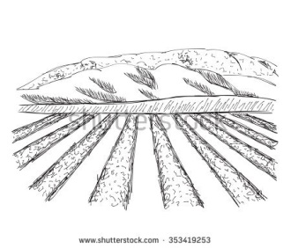

SOIL

**5.3 MODULE DESCRIPTION**

The Arduino is the heart of the proposed embedded system. It constantly monitors the digitized parameters of soil moisture sensor and verifies them with the predefined threshold values and checks the condition for dry and wet, and correspondingly the relay is made ON or OFF.The automatic irrigation system switches the pump motor ON/OFF on sensing the moisture content of the soil, performing plant watering mechanism automatically. Sensing the soil condition using moisture sensor– whether the soil is wet or dry, and the input signals are then sent to the arduino based microcontroller, which controls the whole circuit.

**5.3.a FLOW CHART**

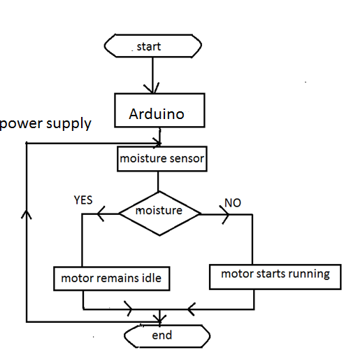

**Fig 5.3.a**

**6. IMPLEMENTATION**

In this project, two sensors can be connected to analogue pins, A0 and A1, of the Arduino board. Each sensor has four pins (Vcc, Gnd, Ao and Do) available for interfacing with the Arduino board. Here, digital output pin (Do) is not used. The water pump and motor are controlled by Arduino connected to digital pins 3 and 9, respectively. That is, the motor signal control pin is connected to pin 9 of the Arduino board.

The program in the Arduino reads the moisture value from the sensor every 20 seconds. If the value reaches the threshold value, the program does any of the following:   
1. It runs the motor , along with the water pipe fixed on it, toward potted plant, whose moisture level is less than the predetermined/ threshold level.  
2. It starts the motor and supplies water to the plant for a fixed period of time and then stops the motor.

It works as follows-

The SENS1 is the module for sensing the moisture of the soil. The result of the module is either HIGH or LOW.

The results are

Wet = HIGH and Dry = LOW.

The Pump module send data to the electric circuit to turn motor pump automatically.

The results are

Bit = HIGH; turns on the motor pump, Bit = LOW; turns off the motor pump.

The system module starts with memory allocation for storing the modules SENS! And Pump at p1 and p2 pointers respectively.

**PSEUDO CODE**

1. Start

2. Assignment of I/O pins to desired variables

3. Initialize memory locations for the modules involved as Sensor, Pump and main Program to their starting values

4. Check the soil moisture sensor module output

5. If bit returned = HIGH go to step 4 else process with next step

6. Set input bit to Pump module as HIGH and jump to Pump module for turning on the motor pump.

7. Create a delay to run the motor for sufficient time to water the soil

8. Clear the input bit to Pump module as LOW and turn motor pump off.

9. Create a delay for checking the moisture sensor

10. Compare sensor level and if same return else return to step 4.

**SOURCE CODE**

int ACWATERPUMP=13;

int sensor=8;

int val;

void setup() {

pinMode(13,OUTPUT);

pinMode(8,INPUT);

}

void loop() {

val=digitalRead(8);

if (val==LOW)

{

digitalWrite(13,LOW);

}

else

{

digitalWrite(13,HIGH);

}

delay(400);

}

**7. CONCLUSION**

This project is done by grouping the hardware and software that provides a watering controller which is implemented at comparatively low cost and which is enormously user friendly. The circuit is used to evaluate the loss of moisture in the soil overtime due to evaporation and intake. It minimizes water waste and improves plant growth. It is designed to work automatically and hence, there is no need for any human intervention. This project is mainly designed for residential environment and small gardens. Hence the same project circuit can be expanded by using the advanced soil moisture sensor for a large agricultural fields.

The main advantage of the project is to reduce the involvement of human and still making it certainly to get the appropriate system with the maximum efficiency.

**8. FUTURE WORK**

The opinion in future can be amended by joining in the GSM technology, in such a way that every time the water pump switches ON/OFF, an SMS is provided to the apprehensive individual regarding position of the pump whether the pump is ON or OFF at a current period of time. We can also govern the pump through SMS. The project should give accurate soil moisture content. The implementation should be of low cost and highly reliable. It must be able to reduce the man power. System must be alternative to switching to manual mode whenever required it should be highly efficient.

**9. SCREENSHOT**

